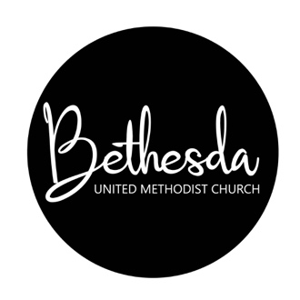
Bethesda United Methodist Preschool
Angie Crawford, Teacher
Kayla Spencer, Teacher
118 Bethesda Drive, Ona, WV 25545
(304) 638-1174

4 & 5-Year-Old Class
M-W-F (9 am-12 pm)
$90/Month
3-Year-Old Class
T-R (9-11:30 am)
$70/Month

Biographical Information:

Child’s Name: Nickname:

Current Age: Birthday: Today’s Date: 3/25/2020

Parent/Guardian Name(s):

Address:

Telephone: (primary) (secondary)

Place of Employment:
Parent/Guardian: Parent/Guardian:
Employer: Employer:
Work Phone: Work Phone:

Secondary Emergency Contacts:

Name: Name:
Address: Address:
Telephone: Telephone:
Relationship: Relationship:

Immunizations:

To Begin Preschool, Children Must Be Up to Date on All Immunizations.
Check Here to Confirm That Your Child Is Up to Date on All Immunizations:

Help Us Get to Know Your Child:

Siblings:
Name: Name: Name:
Age: Age: Age:

Has Your Child Had Much Experience Playing with Other Children?

Are There Any Health Concerns, Allergies, Snack Limitations, Etc. That We Should Know About?

Who Will Pick the Child Up from Preschool the Majority of the Time?

_____________________________________ _____________________________________
Parent Signature Print Name

Mail Completed Application To:
Angie Crawford
90 Red Hawk Lane
Ona, WV 25545
Please Include Non-Refundable $5 Application Fee.
Checks Payable to BUMP
(Bethesda United Methodist Preschool

